# ANNEXURE I

**PROJECT GUIDE REGISTRATION FORM**

**(To be submitted to the Project Steering Committee) Instruction: Please provide the below details about your Proposed Project Guide.**

1. Name of the Proposed Project Guide: Dipali Borade
2. Date of Birth: 24/11/1999 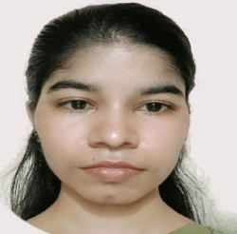
3. Present Employer: NeoSoft
4. Designation: Software Engineer
5. Contact Details: 9011537369
   1. Residential Address: Chinchwali
   2. Office Address: Mumbai
   3. All communications are to be sent to Residential/ Official address (tick anyone)
   4. Contact No.: 9011537369
   5. E-mail id: [boradedipali81@gmail.com](mailto:boradedipali81@gmail.com)
   6. Linkedin id : https://www.linkedin.com/in/dipali-borade-348384202/
6. Education Qualification (start with the highest qualification): (Please attach photocopies of degree certificates)

|  |  |  |  |  |  |
| --- | --- | --- | --- | --- | --- |
| S. No. | Name of the  Degree | Specialization | Year of Passing | Institution/University | Class Obtained |
| 1 | BE | Computer  science | 2021 | University of Mumbai | 9.17 |
|  |  |  |  |  |  |
|  |  |  |  |  |  |
|  |  |  |  |  |  |

1. Area of Specialization/Interest: MERN Stack
2. Total yrs. of Experience: (Please attach photocopies of Experience letters)

|  |  |  |  |  |
| --- | --- | --- | --- | --- |
| S.  No. | Name of the  organization | Designation | From | To |
| 1 | NeoSoft | Software Engineer | 1ts July  2021 | Till now |
|  |  |  |  |  |

I hereby declare that the information provided by me is true. I agree with the rules and regulations given by the University.

Dipali Borade

**Signature (Proposed Guide)**

# (FOR OFFICE USE)

Following details have been verified

|  |  |  |  |
| --- | --- | --- | --- |
| **Sl. No** |  | **Yes** | **No** |
| 1 | Qualification |  |  |
| 2 | Experience |  |  |
| 3 | PAN Card (in case of Domestic Guide) |  |  |
| 4 | Passport (in case of Foreign Guide) |  |  |
| 5 | Approved for Department / Specialization |  |  |

**Signature Signature**

**(Faculty in-charge) (Project Steering Committee)**

(Note: Filled in Registration forms must be scanned in either .pdf / .doc format and submitted along with credentials (Scanned copy of Degree Certificates, PAN Card

(for Domestic Guide), Passport (for Foreign Guide) and Experience Certificates of the proposed guide) on LMS portal- link).

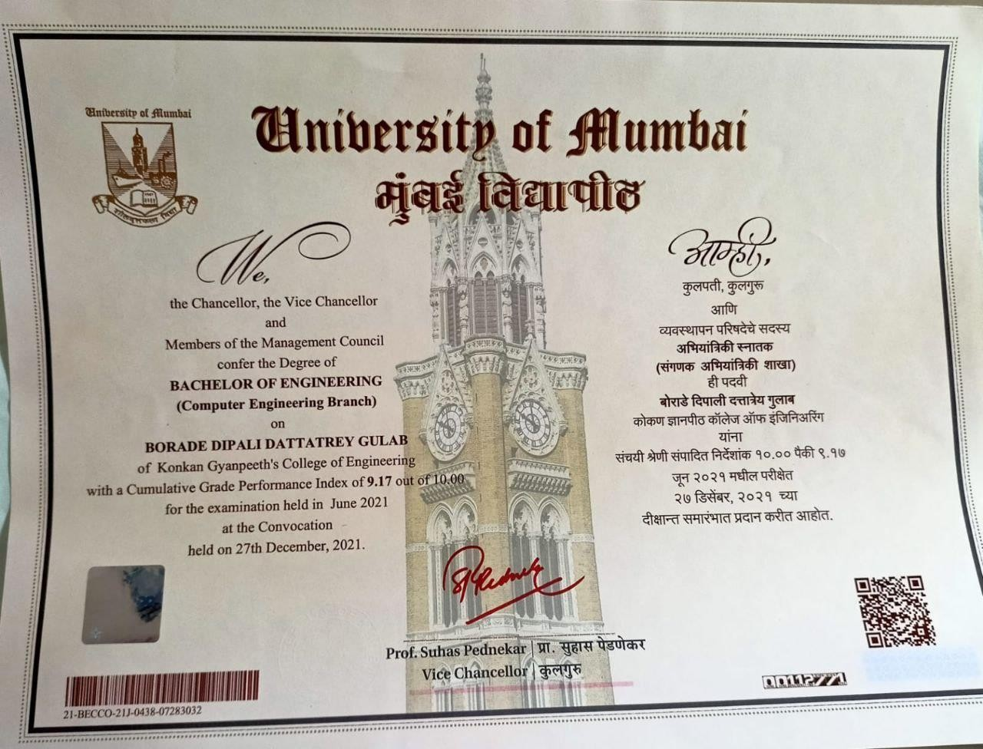Degree

Identit_Card

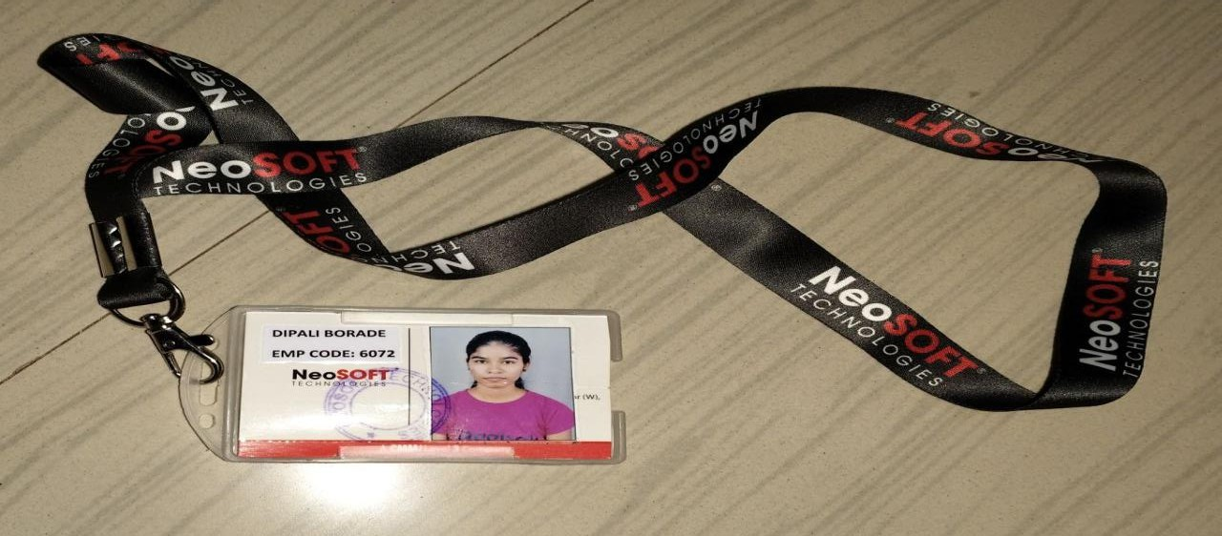

Date of joining letter



**Ms. Dipali Borade** At.Eksal, Tal. Karjat, Dist.Raigad, Post.Chinchawali Maharashtra.

Pin Code - 410201.

**Subject: Confirmation Letter**

**Date : 1st January, 2022**

**Dear Dipali,**

Consequent to the review of your performance during **01st July 2021 to December 2021**

we have the pleasure in informing you that your services are being confirmed as

***“*Trainee Software Engineer*”*** with effect from **January 2022.**

**Kindly note that your compensation is personal confidential information of the company. Anydiscussion or disclosure of your compensation with anybody other than your departmental head or HR will be considered as breach of agreement by you.**

**Performance linked incentives are paid annually if any.**

All the other terms and conditions as detailed in your appointment letter remain unchanged.

**For NeoSOFT Private Limited**



**Ms. Simran Singh**

**(Associate Vice President – HR)**



